(Jewels Photo)

“Chicks Connect is more than a membership, it is a movement. Chicks are agents of change, doing much more than simply supporting women in business with referrals and marketing ideas. Becoming a member requires one to look deeper within oneself to live a fuller, more vibrant life, while helping members take the time for self-discovery and self-care on every level. Whether you’re a young mother with a home business, an on-the-go professional, or an empty-nester entering the job market, Chicks Connect is supportive of your business, relationships and life’s challenges.”
-Jewels Muller, Chief Chick of Chicks Connect

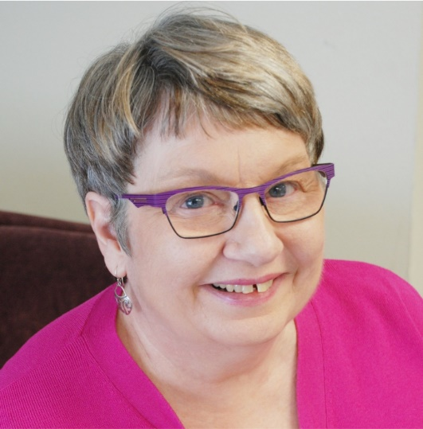(Leslie’s Photo Here)

Leslie Ann
“The women in Chicks Connect are agents of change, doing much more than simply supporting women in business with referrals and marketing ideas. Becoming a member requires one to look deeper within oneself to live a fuller, more vibrant life, while helping fellow chick members take the time for self-discovery and self-care on every level. Whether you’re a young mother with a home business, an on-the-go professional, or an empty nester reentering the job market, Chicks Connect is supportive of your business, relationships and life’s challenges. What could be better than that?”
~Leslie Ann, Lake Oswego Graphics

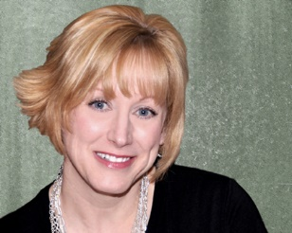Chicks Connect – More than Just a Networking Group

It’s a Movement
By: Margaret Harmon

Chair Chick of the New Jersey Peeps

I often get asked, “What’s the big deal about Chicks Connect? Why is it so different or special compared to other groups, organizations or clubs?” The short answer is: it’s unique because it is a movement that women can become a part of where they participate in a mastermind growing personally and professionally. Women are bonded into a new type of network that supports them no matter where they are and what stage of life they find themselves.
Now here is a more involved answer. I recently read a blog about a woman that was “ubber” successful, she had money, prestige, recognition, accomplishments, and her wall was covered with all the plaques, awards, and photos of the famous smiling with her. Secretly inside she was miserable both personally and professionally. Addiction became her anesthetic to numb her pain and keep reality at bay. Then she crashed and found herself in a very dark, lonely and scary place. After becoming sober and lots of therapy she was asked what she had learned. The answer was simple. Everyone needs a net. Nets are groups of people who watch out closely for each other and notice when someone needs help and then gives help. Sometimes we have nets in our churches, neighborhoods and schools and social circles. Because of the complex demands on women today and the many roles they have, often women neglect their needs and are walking the high wire of life with no nets or very weak superficial nets.
So imagine being able to have one huge net that was dedicated to inspiring you to grow personally and professionally by connecting, supporting and encouraging you, while you did the same for other women. Being able to learn and grow from the weekly curriculum and find support in all areas like the ones mentioned and many others.

Inspiration, Accountability, Love, Fun and Support are a few of the amazing benefits of coming together and joining and or forming Chicks Connect Chapters.
Sometimes we laugh until we need a Depends, or we cry until we are laughing. We listen to each other and we are heard when we speak, by the way that is HUGE! We can share our mistakes and forgive ourselves or others that just don’t get it. Sometimes we are challenged and other times we show up and are able to breathe, rest and renew. Often we teach and as my teens would sometimes say, “we get schooled”. It is real and we don’t have to pretend to be wearing the uniform of Superwoman with an “S” emblazoned between our boobs, stressing and thinking that we can do it all and never want for anything, all while looking like a super model wearing 5 inch heels.
Women are helped; resources shared, lifelong friendships are made because of the unique combining of education + inspiration + accountability. The stories of overcoming adversity, learning from the experience and taking action to make positive changes in your life and the lives of others, makes this a powerful group. When coming together with other women, you will find that you are not alone in your challenges; personally and professionally and you will learn from the lessons already lived.
What we all want is success. Success in our relationships, wellness, business, fun, family life and love of self. You will find you have a huge net that is dedicated to you, your happiness and success. Take the time to invest in yourself, you deserve it. It does not matter how old or young you are, or what you do from CEO to entry level to Mom/Grand mom or reinventing yourself. Through the regular Chicks Connect mastermind meetings and this amazing partnership of women – growth and success happens. We show up for ourselves and others. We are Chicks Connect.
So that’s my story and I’m sticking to it.
__________________________________________________________________
Chicks Connect is a Mastermind Support Network dedicated to connecting women on a global level, guiding them into action and holding them accountable for personal and professional growth and development all built on a foundation of love, fun, friendship, service and support. There is a membership fee of $27 monthly for Chicks Connect. We welcome all of you to join our Chicks Connect Sisterhood. We have launched our first chapter here. You will see the chapter meetings posted. If you are interested in our membership and want to join, we encourage you to sign up with one of the current Chicks Connect Members listed here.
In the North Burbs, First Monday of the Month @ Signature Sweets, 6 p.m.
Contact Phyllis Benstein @ 847) 910-6039
In NW Indiana, 2nd and 4th Friday of the Month, Spring Mill, Merrillville, IN, 9 a.m. to 10:30 a.m.
Contact Christine Neal @ 219) 670-2111
Interested in joining or starting your own Chicks Connect Group….Get the link on our Website.
www.FabulousOver50.com/ChicksConnect
Chicks Connect Photo 1
Chicks Connect is all about building relationships, pictured Maria Locatell and Denese Brown.

Chicks Connect Photo3: Kristy Jarrett - Lynn Deal - Dr. Joan Schultze - Leslie Ann Aken - Diane Mead all of the Lake Oswego Chicks Connect.

